**DECLARATION OF CONFORMITY**

**Manufacturer:**

CID Bio Science, Inc.

1554 NE 3rd Ave

Camas, WA 98607

**Declares that the CE-marked Product:**

**Product Model(s):**

Model CI-202

**FCC Compliance Statement:**

This device complies with part 15 of the FCC Rules. Operation is subject to the following two conditions: (1) This device may not cause harmful interference, and (2) this device must accept any interference received, including interference that may cause undesired operation.

**Complies With:**

89/336/EEC Electromagnetic Compatibility Directive

73/23/EEC Low Voltage Directive

**Compliance Standards:**

EN 55027 RF Emissions Information

Technology Equipment

EN 50082-1 EMC Immunity Standard

EN 60950 Safety of Information

Technology Equipment

Including Electrical

Business Equipment

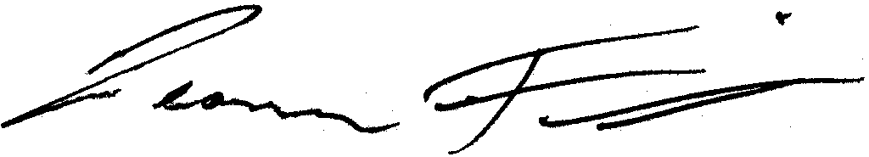

December 18, 2013

Leonard Felix

President

**DOCUMENT OVERVIEW**

INTRODUCTION 3

CI-202 Specifications 4

Features 4

Operating Instructions 6

Measure 6

View Data 7

Manipulate Files 8

Transfer Data from a File 9

Clear a File 9

Delete a File 10

Create a File 10

Close a File 11

Set-Up Instrument 11

Set-Up Measure Parameter 12

Set-Up Scanner Thresholds 12

Manual Threshold Adjustment 12

Set-Up Storage (check space or erase) 13

Set-Up Auto Store Parameter 14

Calibrating the CI-202 15

CI-202 Threshold Set-up Procedure 15

CI-202 Care 19

Charging the Battery 19

Cleaning 19

THEORY OF OPERATION 20

Overview of the Parts of the Instrument 20

The Width Scanner 20

Computing the Parameters 20

Computing Aspect Ratio and Shape Factor Information 21

TROUBLESHOOTING 22

Updating the Firmware 22

Troubleshooting the LIBUSB.dll Error 23

Technical Support 25

Customer Service 25

Frequently Asked Questions 26

CID Hardware Warranty 29

CI-202 PRODUCTION TEST CHECK SHEET 31

**NOTE:** This equipment has been tested and found to comply with the limits for a Class A digital device, pursuant to Part 15 of the FCC Rules. These limits are designed to provide reasonable protection against harmful interference when the equipment is operated in a commercial environment. This equipment generates, uses, and can radiate radio frequency energy and, if not installed and used in accordance with the instruction manual, may cause harmful interference to radio communications. Operation of this equipment in a residential area is likely to cause harmful interference in which case the user will be required to correct the interference at their own expense.

Warning: This equipment has been tested and found to comply with the limits of CISPR 22 and EN 61326-1:2006 Class A. These limits are designed to provide reasonable protection against harmful interference when the equipment is operated in a commercial environment. This equipment generates, uses, and can radiate radio frequency energy and, if not installed and used in accordance with the instruction manual, may cause harmful interference to radio communications.

Warning: This is a Class A product. In a domestic environment, this product may cause interference in which case the user may be required to take adequate measures.

# INTRODUCTION

Congratulations on the purchase of your new CI-202 Portable Leaf Area Meter. Making leaf measurements in the field or laboratory is now very easy with the CI-202 Portable Leaf Area Meter. This state-of-the-art instrument has been designed to be the most portable leaf area measurement system available. Although you are anxious to use your new meter, please take the time to read this manual first.

A picture containing device

Description generated with high confidence

*Figure 1. CI-202 Portable Leaf Area Meter*

## CI-202 Specifications

|  |  |
| --- | --- |
| Scanner: | 670 nm Laser Diode |
| Laser specifications: | Class 3R  Power output of 4.25 mW |
| Max. Measuring Length: | 36cm |
| Max. Measuring Width: | 150mm |
| Max. Measuring Thickness: | 15mm |
| Max. Scanning Speed: | 127 mm/second |
| Area Units: | cm2 |
| Accuracy: | ±1% for samples > 10cm² |
| Resolution: | 0.01cm2 |
| Data Storage: | 8,000 Measurements |
| Computer Interface: | USB 2.0 |
| Display: | 16 characters × 2 line LCD |
| Battery: | 7.2V rechargeable NiMH |
| Battery Life: | 15hrs |
| Operating Temperature: | 0-50ºC |
| Weight: | 1.50 Kg |

## Features

* Quick, non-destructive measurements
* Precise and accurate
* Measures area, length, width, and perimeter
* Will store up to 8,000+ data points
* Download data and recharge via USB on your laptop in the car or the field
* Durable and lightweight
* Ideal for field use
* Calculates shape factor and aspect ratio
* Single self-contained instrument with built-in LCD display
* Samples may be scanned on the scan board.
* No calibration required

# Operating Instructions

The CI-202 is a self-contained, hand-held instrument with a built-in display and batteries. It contains an optical scanner to measure width.

Taking a measurement can be as simple as turning the instrument on, inserting a leaf on the scan board, and scanning. The instrument does the rest.

To turn the instrument on or off, press the ON/OFF button. When the instrument comes on, a copyright notice will appear for 1/2 second. Following this, several words will appear on the display with the word “Measure” appearing in the upper left-hand corner of the display. You are now in the CI-202 menu system.

**Note:** When there are no files to store data to, the measure menu items will not be available. To correct this situation, create a file.

The following sections describe the menus and what they do. The CI-202 menu system allows you to quickly and easily operate the instrument without constantly referring to this manual. Whenever possible, the screen associated with a menu item will give you information about choices that you can make. Usually, the top line of the screen will contain information about where you are, and the bottom line will contain information about buttons to press to change the current status.

## Measure

In the measure mode, the top line of the screen will show the word “Measure” on the left, and the name of a file on the right. The bottom line of the screen will have the word “start” in brackets on the left, and the four direction arrows on the right.

|  |
| --- |
| Measure file00  <start> !"#$ |

The options are:

* to select another mode with the up or down arrow keys
* to select another file (if there is more than one file) with the right or left arrow keys
* to take measurements

To start measuring, hit the enter key or the start key. This begins the measurement process. The motor will start spinning up to speed as soon as the button is pressed, and the display will read “Stabilizing”, then “Spinning Up”, then “Measuring”. At this point, move the scan head down the scan board. When the scan head has been drawn out completely, the instrument will stop automatically and display results of the measurement. At this point, preview the results, and decide whether it should be saved and to which file it should be saved to. The enter key will cause the scanner to start and then the instrument will start measuring; if motion is not detected within a few seconds, the scanner will shut down. The start key does the same thing, but if it is held down, the scanner keeps spinning until you are ready to measure.

The display will show the name of the current file in the upper left-hand corner of the screen, parameter name in the lower left-hand corner and parameter value in the lower right-hand corner of the screen.

**Note:** Because of the amount of information displayed on this screen, the CI-202 cannot display any prompts in this mode.

|  |
| --- |
| file00  area = 44.04 cm2 |

To bring another parameter into view, press the RIGHT or LEFT arrow key. Repeatedly pressing the right arrow key will step you through area, length, width, perimeter, aspect ratio and shape factor, in that order. Only parameters that can be saved to the current file will be displayed. If changes are required before data is saved, use the up and down arrow keys to step through the files. To discard the measurement, press the STOP button. Another measurement may be taken at this time, if required. Depending on the set-up of the automatic save function of the instrument (see Set-up Auto Store parameter section in the main section of this manual) the measurement will or will not be saved.

To save the measurement, press the SAVE button. If the instrument is able to save this measurement, the word “saved” will flash on the bottom line of display to confirm the data saved. If there is insufficient storage space to save the measurement, the instrument will flash the message “no room!” on the bottom line of the display.

## View Data

In the view mode, the top line of the display will show the word “View” on the left and the name of a file on the right. The bottom line will show the word “enter” on the left and the four direction arrows on the right.

|  |
| --- |
| View file00  <enter> !"#$ |

The options are:

* to select another mode with the up or down arrow keys
* to select a file (if there is more than one file) with the right or left arrow keys
* to view battery life
* to view voltages
* start the viewing process by pressing the START/ENTER button

**Note:** Because of the amount of information displayed on this screen the CI-202 cannot display any prompts in this mode.

|  |
| --- |
| file00 total  area = 345.0 mm2 |

One of three things will be displayed: the most current measurement sequence number, the average of all measurements, or the total of all measurements. The bottom line will display the parameter name on the left side and the parameter value on the right side.

To bring another parameter into view, press the RIGHT or LEFT arrow key. Repeatedly pressing the right arrow will display area, length, width, perimeter, aspect ratio and shape factor in that order. To bring another measurement into view, press the UP or DOWN arrow key. Pressing the Up-arrow key will display the total values for all measurements in the file in the following order: The first value shown is the average value for all of the measurements in the file, the most recent measurement in the file and on through the first measurement taken. Next, return to the total again. Think of this view mode as a computer spreadsheet that only allows the user to view one cell at a time.

To return to the main view mode, press the STOP/RESET key.

To view battery life, arrow right or left until “View Battery” is displayed. Hit enter and it will display battery life left.

## Manipulate Files

The CI-202 gives an expanded ability to organize data collection by using a file structure similar to that used by personal computers. The CI-202 has up to 256 files available. Select a unique name for each file to control the data stored in each file to optimize the amount of data stored for research that is carried out.

The file mode capabilities are: Clear, Delete, Create, and Close files. While in the *file mode*, the top line of the screen will read “files” on the left and one of the words “Clear”, “Delete”, “Create”, or “Close” on the right. The bottom line of the display will read “enter” on the left and the four direction arrows on the right.

The options are:

* to select another mode, use the up or down arrow keys
* to select a particular action to carrying out on files, use the right or left arrow keys
* to start the selected action, use the START/ENTER key

### Transfer Data from a File

Data can be downloaded from the CI-202 to a PC at any time the instrument is idle. Plug in the USB cable to both the instrument and the PC and run the CI202dfV1006.exe program on the PC (downloadable on the CID Bio-Science website). Power on the CI-202. Pressing the folder icon will open an additional window with all of files saved on the CI-202. From here you can download files, save files to the PC, and print files.

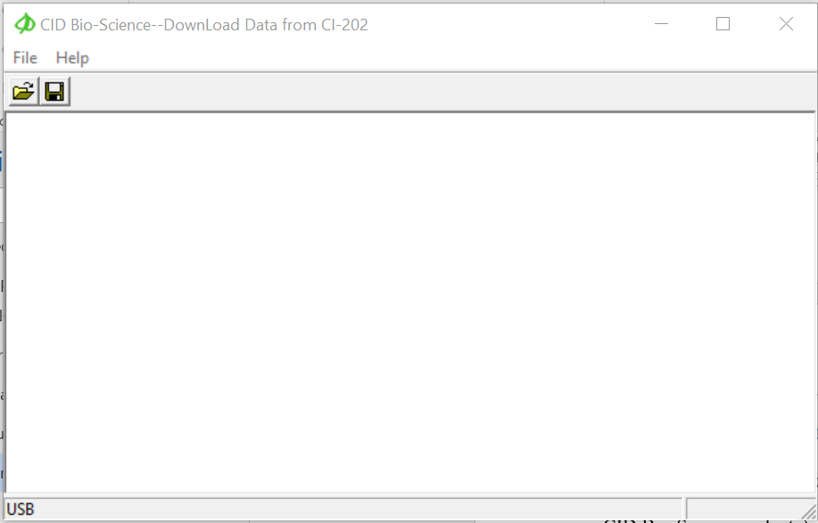

Under the file menu option on the CI-202, the four possible actions available are as follows:

### Clear a File

When the START/ENTER key is pressed, “clear filename” is displayed on the top line, indicating the unit is ready to clear the file with the name filename. Selecting enter will clear the data from the selected file but keep the filename active for future data collection.

|  |
| --- |
| clear file00  <enter><stop> !"#$ |

### Delete a File

Pressing START/ENTER when “Delete files” is displayed on the top line indicates the unit is in the *delete file* mode. This mode will erase a file completely from memory. In this mode, the top line of the display reads “Delete” on the top left line and the name of a file on the right. The bottom line of the display reads “enter” on the left and the up and down direction arrows on the right.

|  |
| --- |
| Delete file00  <enter> !"#$ |

To delete a file, use the UP or DOWN arrow keys to select a file. Once a file is selected to be deleted, press the START/ENTER key. The instrument will confirm the deletion with the line “<erase> <stop>”. To delete the file, press the SAVE key. To escape without deleting the file, press the STOP key.

### Create a File

When the START/ENTER key is pressed, “Name: Files” is displayed on the top line, indicating the unit is in *create files* mode. The top line of the screen will read “Name” on the left, and a file name (e.g. “file00”) on the right. The bottom line will read “enter” at the left, “erase” at the center, and the four direction arrows at the right.

**Note:** The Stop key can be pressed at any time to abort the file creation process and to return to this point.

|  |
| --- |
| Name: file00  enter erase !"#$ |

Pressing the arrow keys will allow an alpha or numeric selection for a six-character file name. The right and left arrow keys select which character in the file name to edit and the up and down arrow keys are to choose a character. The chart below lists the available characters.

|  |
| --- |
| ! " # $ % & ' ( ) * + , - x / 0 1 2 3 4 5 6 7 8 9 : ; < = > ?  @ A B C D E F G H I J K L M N O P Q R S T U V W X Y Z [ ¥ ] ^ _ |

Pressing the SAVE/ERASE key in the "Create files" mode deletes the character under the cursor. Also, characters cannot be inserted. After naming the created file, press the START/ENTER key twice to continue the file creation process by entering Parameter Set-Up. Should the file name be identical to another file name, the instrument will display the message “duplicate name” on the top line of the display and “enter” on the bottom. All the data is stored no matter what the YES/NO flag is set to for area, length width, perimeter, ratio, and factor. If the Root Length flag is set to YES, then only length is stored, but the record length and number of measurements possible is unchanged.

When entering file Parameter set-up, the top line of the display reads the name of a parameter at the left and the word “yes” or “no” at the right. This indicates whether the particular parameter will be flagged for display. The bottom line of the display will read “enter” at the left and the four direction arrows at the right.

***Note: “Root Length” Parameter must be set to “No” when “Setup Measure” mode is set to measure “Leaf.”***

|  |
| --- |
| area yes  <enter> !"#$ |

To set a flag for a parameter, select the parameter and press the DOWN key. The word on the top right of the display will change from “yes” to “no” and that parameter will be flagged to not display. To set the flag to display a parameter, select the parameter and press the Up-arrow key; the word at the top right of the display will change from “no” to “yes”.

Once finished setting up the parameters for the file, press the ENTER key. The file confirmation screen will appear. Press ENTER, again, for confirmation to create the file, or press STOP to abort the process.

|  |
| --- |
| file00 created  <enter> <stop> |

### Close a File

Closing a file will move all temporary records to the file system. This will keep the records from being lost should the battery be unplugged while the instrument is on. It may also assist in downloading the temporary records to a PC.

## Set-Up Instrument

The CI-202 has a number of utility functions that allow the user to manage the instrument’s capability. These functions are accessed using the *setup* mode. When the instrument is in the *setup* mode, the top line of the display reads “Setup” on the left and one of the words “Measure”, “scanner”, “auto save”, or “storage” on the right. The bottom line of the display reads “enter” on the left and the direction arrows on the right.

|  |
| --- |
| Setup Measure  <enter> !"#$ |

The options are:

* To select another mode using the up or down arrow keys
* To select an area to set-up using the right or left arrow keys
* To begin the set-up process by pressing the START/ENTER key

### Set-Up Measure Parameter

Pressing the START/ENTER key when the “Setup Measure” is displayed on the top line allows the unit to select between Leaf Area or Root length modes.

|  |
| --- |
| Measure = Leaf  <stop><save> !"#$ |

Use the up or down arrow keys to modify the value. Once satisfied with the set-up parameters, press the SAVE key. To avoid saving the parameters, press the STOP key to abort the process.

### Set-Up Scanner Thresholds

**Note:** Normally, there is no need to adjust the threshold of the CI-202 because the instruments are factory-adjusted to a threshold level that is ideal for “all-around” use.

### Manual Threshold Adjustment

First, adjust the threshold with the CI-202 over the reflective tape of the scan board. Select “Setup Scanner” in the display window and press START. Select “HiThrld” and press START again. Write down the threshold value displayed. Place a piece of white paper so it covers about half of the laser scan area starting at the right-hand side (away from the rail). Select “LoThrld” and press START. Again, write down the threshold value displayed.

First, calibrate the instrument alone with the instrument over the reflective tape of the scan board. Select “Setup-Scanner” from the menu, then select “Manual” and press ENTER. The motor should spin, and the laser should come on. The display should show something like this:

|  |
| --- |
| T = 47 w = 0  <stop> |

The “t” value is the threshold and the “w” is the width (in pixels) that the instrument is reading. Use the up/down arrows to adjust the “t” value to 10 above the LoThrld value you wrote down above. The HiThrld value must be at least 15 more than the new “t” value.

Press STOP to shut off the laser and motor. Press STOP again and press SAVE if you want to keep the new threshold. Press the down arrow to get back to the Measure display. Press both the left and the right arrows at the same time. The CI-202 will turn on the laser for a short period while it measures the width. Press the up arrow and then the ENTER key to get back into the setup scanner menu. Press the SAVE and STOP keys at the same time. A new display will appear that allows you to see the precharge and other factory settings. Do not make any changes to these settings. Press STOP and then STOP again. The instrument will ask “Save changes? Press SAVE”. Test the instrument to see if it is working.

If the instrument malfunctions after manual threshold adjustment, contact CID, Inc. for assistance.

### Set-Up Storage (check space or erase)

Pressing the START/ENTER key when “Setup storage” is displayed on the top line indicates the unit is in the *storage setup* mode. It will always start by indicating the total amount of storage space that is in the instrument for files and data.

The top line of the display will read “space =” to the left, and the number of bytes to the right (16 bytes are used per measurement record). The bottom line of the display will read “stop” on the left, and the up and down arrows on the right. Press the stop key to escape this mode, or the up and down arrow keys to reach the format storage menu.

.

|  |
| --- |
| space = 128k  <stop> #$ |

Pressing the START/ENTER key when “format storage” is displayed on the top line indicates the unit is in the *storage format* mode. Be careful! Formatting the storage space of the CI-202 will erase all data and all files. This is convenient when starting a new year’s work, for example, but treat this command with care.

In the format storage mode, the top line of the display will read “Clear all data”. The bottom line of the display will have the word “stop” to the left and “enter” to the right.

|  |
| --- |
| Clear all data  <stop> <erase> |

To delete every file in your instrument, press the ENTER key. The instrument will erase all data from memory, leaving the maximum possible amount of memory for use. To stop the deleting process, press the STOP key.

***NOTE: When there are no files to store data to, the measurement menu items will not be available.*** ***To correct this situation, create a file.***

### Set-Up Auto Store Parameter

Pressing the START/ENTER key when “Setup auto store” is displayed indicates the unit is in the *setup auto store* mode. This allows the user to set-up the instrument to automatically store measurements, and to start a new measurement without explicitly saving the old one. This mode is convenient when taking fast, repetitive measurements and when it is not necessary to review each measurement.

In the *auto store setup* mode, the top line of the display will read “auto store =” on the left and either “yes” or “no” on the right. The bottom line of the display will read “stop” and “save” and the directional arrows.

|  |
| --- |
| auto save = yes  <stop> <save> #$ |

To set the instrument up to automatically store measurements press, the Up-arrow key to bring the word “yes” onto the display, then press the SAVE key to save the configuration. To set the instrument up to automatically discard measurements, press the DOWN arrow key to bring the word “no” onto the display, then press the SAVE key to save the configuration. To avoid changing the configuration, press the STOP key.

# Calibrating the CI-202

Occasionally the CI-202 needs to have the timing parameters re-computed or the threshold adjusted to bring the instrument back to measuring accurately. Each time a parameter is adjusted on the CI-202, the instrument should have its timing parameters re-computed the next time it is powered on. The CI-202 can require adjustment after extensive use in the field or downloading/updating firmware. The recalibration is very quick and simple. After recalibrating, the high and low thresholds should be checked and readjusted if necessary.

* Power the instrument on. The image below should be displayed on the instrument’s screen.

Measure file01

<start> !"#$

* Press the LEFT and RIGHT arrow keys at the SAME time.
* The motor will begin to start-up and spin. This step is quick, and the motor typically spins for about four seconds.
* Next, the motor will stop spinning. During this time, the display on the screen does not change.
* Scan a leaf or piece of paper of known size to test the accuracy of the instrument.
* The high and low thresholds should be checked and adjusted if necessary.

## CI-202 Threshold Set-up Procedure

The instructions below begin with checking the ***filter*** of the unit. This is done in Root Mode (steps 1-14). Next, the thresholds are checked and adjusted for ***Root Mode*** (steps 15-27). Beginning at Step 28, the unit is switched to Leaf Mode. The procedure can be started at Step 28, but it is recommended to perform all the steps all the way through. The ***Leaf Mode*** section (steps 28-43) explains how to check and set the thresholds for leaf measurements. If the scanner is not providing an accurate width reading, steps 44-47 provide the instructions for accessing and adjusting the ***Scan Width*** of the unit. If the length measurements are not correct, steps 48-52 focus on adjusting the ***Step Length***, which is very important for instrument accuracy.

1. Turn unit on by pressing the POWER button. R
2. Use the UP or DOWN arrow to scroll until you see “Set-up Auto save”
3. Use the RIGHT arrow to scroll to “Set-up Measure.” Press ENTER.
4. Use the UP or DOWN arrow to get to “Measure Root.” Press SAVE. The screen will flash “measure root saved.” Then the screen will show “Set-up Measure.”
5. Use the RIGHT arrow key to scroll to “Set-up Scanner.” Press ENTER. You will see “HiThld Scan.”
6. Use the UP or DOWN arrows to scroll to “filter scan.” Press ENTER. You will see “Filter on On or Off”
7. Use the UP or DOWN arrow key to get to “Filter off.” Press STOP TWICE and then SAVE. The screen will flash “Root params saved” indicating that the root parameters have been saved. This will turn the filter off and save the changes.
8. The screen will come up “Set-up Scanner.” Press ENTER.
9. Use the UP or DOWN arrow key to get to “Manual Scan.” Press ENTER.
10. You will hear the motor start and the laser line will come on.
11. With the laser line over the reflective material only watch the “w” value. It should read the value as w = 1.
12. When you MOVE the laser scanner over the inspection standard, the “w” value should read 2. Press STOP. The inspection standard is a piece of white paper with known length and width.
13. Use the UP or DOWN arrow to scroll to “Filter Scan.” Press ENTER.
14. The value in the bottom center of the screen should read 1.
15. Using the UP or DOWN arrow, turn the filter on and press STOP TWICE and SAVE (the screen will flash “Root params saved”). This will turn the filter on and save the setting. The screen will come up “Set-up scanner.” Press ENTER
16. Use the UP or DOWN arrows to get to “HiThld Scan.” Press ENTER.
17. You will see the “t” value and “w” value change. Watch the t value closely. The “t” value will go down, then stop and set itself. Note the number it stops and sets at and write down the number setting. It should settle below 50, with somewhere in the 20’s being desirable.
18. Use the UP or DOWN arrow keys to get to the “LoThld Scan.” Place a piece of white paper under the scan area on the right edge.
19. Press ENTER.
20. Again the “t” value will go down. The low threshold will also stop and set itself like the high threshold did in step 17. Write down and note the number setting.
21. Add the HiThld setting number and the LoThld setting number and divide by 2. This will give you your average setting number. Write down and note the number. Remove the white paper from under the scanner.
22. When you have this information use the UP or DOWN arrow keys to scroll to “Manual Scan.” Press ENTER.
23. The motor will start, and you will see the “t” and “w” settings appear. Use the UP or DOWN arrow keys to adjust your “t” value to your average setting number (from step 21).
24. Press STOP TWICE and then SAVE. This will save your threshold settings.
25. Use the DOWN arrow key to get to “Measure file01.” Make sure the scan area is clean and clear.
26. With the laser over the reflective material only, press the RIGHT and LEFT arrows simultaneously. You will hear the motor run briefly and stop. DO NOT MOVE THE SCANNER WHILE IT IS RUNNING.
27. Press the RIGHT and LEFT arrow keys simultaneously one more time. This will calibrate the unit for the Root Mode. (Note: You will follow the same instructions shortly to calibrate the instrument in Leaf mode).
28. Use the UP or DOWN arrow to get to the “Set-up Scanner” and then the RIGHT arrow to get to “Setup Measure.” Press ENTER.
29. Use the UP or DOWN arrows to change the setting to “Measure Leaf.” Press SAVE. The screen will flash “Measure = leaf saved.”
30. Use the UP or DOWN arrow to get to “Set-up Measure.”
31. Use the RIGHT or LEFT arrow to get to “Set-up Scanner.”
32. Press ENTER.
33. Use the UP or DOWN arrow to get to “HiThld Scan.” Press ENTER.
34. You will see the “t” value on the left and the “w” value on the right. The values will drop. Watch the “T” value and note when the numbers stop, and the setting is locked. Note and write down the number.
35. Use the UP or DOWN arrow to get to “LoThld Scan.” Place a white sheet of paper under the scan area. Press ENTER.
36. You will notice again the “t” value will drop. Note and write down the number
37. Add the two threshold values together and divide by 2. This will give you the average. Remove the white paper.
38. Use the UP or DOWN arrow to get to “Manual Scan.” Press ENTER.
39. Using the UP or DOWN arrow, adjust the “t” value to the average setting computed in step 37.
40. Press STOP TWICE and then press SAVE. This will save your threshold setting for the Leaf mode (the screen will flash “Leaf params saved” indicating that the changes made to the leaf parameters were saved).
41. Press the DOWN arrow until the screen displays “Measure file01.”
42. Press the LEFT and RIGHT arrows simultaneously. This will compute the Timing parameters for the unit. REPEAT this step.
43. The display should read “Measure file01.”
44. Use the UP arrow key scroll to “Set-up Scanner.” Press ENTER.
45. Press the SAVE and STOP buttons at the SAME time. This will take you to the hidden menu.
46. Once in the hidden menu, use the RIGHT arrow key to get to “Scan width.” Press ENTER. The motor and laser will turn on. MOVE the scanner onto the standard. Using the UP or DOWN arrow keys, adjust the scan width (the top number) until the width in mm displayed on the screen is the same as the width of the standard paper you are using. Press STOP THREE times and then press SAVE. This will save your adjustments. MOVE the unit down to where the laser line is only over the reflective material.
47. Press the DOWN arrow one time to get to “Measure File01.” Press ENTER and take a measurement of the standard. Press the RIGHT arrow key to get to the length reading. If the measurement is correct for the length, no further adjustments are needed. If the measurement is incorrect, “Step length” adjustments will be necessary while in the hidden menu. Press STOP.
48. To get to hidden menu REPEAT steps 43 thru 45.
49. Once there, use the RIGHT arrow key to get to “Step Length.” If your readings were low, you should raise the step length setting. If the measurements were high, you should lower the step length setting. Once you have made your adjustments, press STOP TWICE and SAVE to save the adjustments.
50. Press the DOWN arrow to get back to “Measure file01.”
51. REPEAT steps 47 thru 49 as needed to calibrate the instrument to the correct length of the standard and the correct width of the standard.
52. Once you have calibrated the unit to read the correct measurements of the standard you are ready to take measurements with the CI-202.

Re-compute the timing parameters of the CI-202 by pressing the LEFT and RIGHT arrow at the same time from the Measure Menu after adjusting the threshold.

# CI-202 Care

## Charging the Battery

When “Low Battery” is displayed, the battery is discharged below the recommended operating level. Measurements may continue for another 15 minutes; however, we recommend the battery be recharged as soon as possible. To charge the battery, plug the instrument into a computer USB port or the supplied charger. The instrument should be turned on while plugged into the USB port of a computer to get the fastest charging. Charge for at least 14 hours to get full charge on the batteries. Storing a battery in a discharged state could permanently damage it.

## Cleaning

Treat the CI-202 as any other fine optical instrument. Keep the lens clean and free from scratches. When not in use, keep the instrument in its protective case. Use only a mild detergent and damp cloth to clean the exterior areas of the instrument. Use a high-quality lens cleaning cloth to clean the window. Do not submerse or use an overly wet cloth to clean the instrument. Do not drop the instrument.

For an extended storage period, we recommend storing the instrument in a cool and dry place.

# THEORY OF OPERATION

## Overview of the Parts of the Instrument

The CI-202 consists of a number of sub-systems. It has a laser width scanner that is capable of measuring the width of an object in its objective 500 times a second to a resolution of 0.1 mm. The entire instrument is controlled by a microcomputer system that allows the user unparalleled flexibility in configuring the instrument to make measurements accurately, easily, and quickly.

## The Width Scanner

When the instrument is in the scanning mode, a rotating mirror causes a laser beam to scan across the objective 500 times a second. This beam is reflected off the special surface of the scan board and received by a light sensor inside the unit. The level from this sensor is compared to a threshold. The output of the “comparator” is fed to the microcontroller, which monitors the intervals during the width scan.

## Computing the Parameters

The CI-202 measures only two parameters directly: width and length. From these it derives area, perimeter, aspect ratio, and shape factor from each scan.

Each time the meter senses the leaf has progressed 1 mm, the computer will check if the width reading is a non-zero value.

If the width measurement is non-zero, the computer takes the following actions:

The width measurement is added to the area accumulator.

If the width measurement is greater than the currently stored maximum width, the maximum width is updated.

The perimeter increment is calculated and added to the perimeter accumulator. This perimeter increment is calculated using the function:

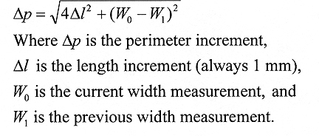

If the width measurement reaches zero and the instrument is not operating as part of the conveyer attachment, the measurement stops and is displayed.

## Computing Aspect Ratio and Shape Factor Information

Aspect ratio and shape factor information can be easily determined from other calculated values. These derived quantities are not stored but calculated, whenever necessary, for the purposes of display or data dumping. The calculations used are shown below.

Aspect ratio is the ratio of the leaf length to its maximum width. It can be calculated from the equation:

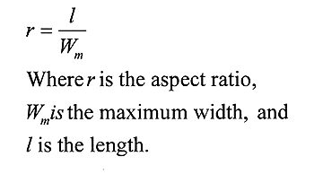

Shape factor is the ratio of the leaf area to the leaf perimeter, corrected so that the shape factor of a circle is equal to one. It can be calculated from the equation:

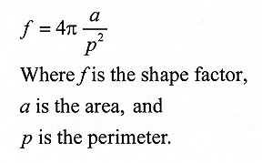

# TROUBLESHOOTING

## Updating the Firmware

If the firmware on the CI-202 needs to be updated or is deleted, follow the steps below to reload the firmware onto the CI-202.

1. Download the ‘CI-202 Firmware UpdateV308 and Driver.zip’ from the software page: <https://www.cid-inc.com/support/CI-202/software/>
2. Extract all

You should now have folder contents as follows:

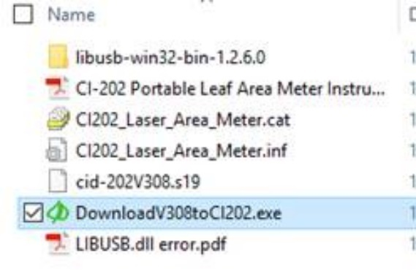

1. Connect the CI-202 to your computer and power on
2. In the download folder, double click on the ‘downloadV308toCI202.exe’
3. In the software window, select File > Open

You should see the following:

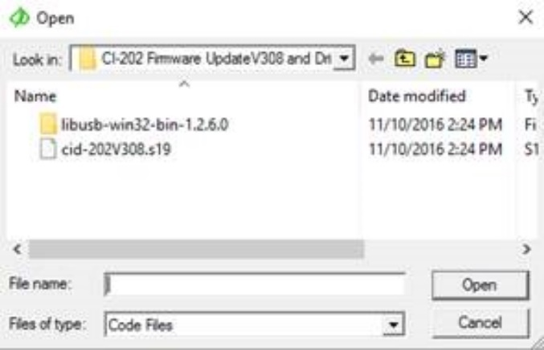

1. Select cid-202V308.s19 > Open

At this point, the CI-202 will start to beep until the firmware is loaded.

Upon completion, you will see ‘leaving OPEN’, and the unit will be powered off

1. Power the instrument on.

The image below should be displayed on the instrument’s screen



1. Press the LEFT and RIGHT arrow keys at the SAME time, the motor will begin to start-up and spin

Next, the motor will stop spinning, during this time, the display on the screen does not change.

1. Scan a leaf or piece of paper of known size to test the accuracy of the instrument, the high and low thresholds should be checked and adjusted if necessary.

## Troubleshooting the LIBUSB.dll Error

The LIBUSB.dll error is typically encountered when trying to install the software and CI-202 to transfer data to a 64-bit computer system.

1. Run a Google search for LIBUSB windows (your operating system) Example: “LIBUSB Windows XP”
2. Select the link for “sourceforge.net”
3. It may say libusb-win32
4. Scroll down the page or find the link to the download site
5. Download libusb-win32-bin-1.2.4.0.zip
6. Save the file and remember where
7. Open the zip file after downloaded
8. Open libusb-win32-bin.1.2.4.0 folder
9. Open “bin” folder
10. Double click the inf-wizard.exe
11. Plug in the device and turn it on
12. Now you are in the Inf-wizard
13. Click next when the CI-202 is plugged in and on
14. Find the device in the list of USB devices: it will most likely be named a set of numbers, such as 0425:0500: if you can’t determine which device is the CI-202, unplug it from the computer and see which one disappears.
15. Select the device and click next
16. Rename the device to CI-202
17. Save CI-202.inf and remember where
18. Click INSTALL NOW button
19. It will install driver and can take some time
20. Select “ok” when installation is complete
21. Go to the CID Software Download Website (<http://www.cid-inc.com/leaf-area/ci-202-software.php>)
22. Download the C202dfV1006.exe – transfers data from CI-202 to PC: Remember where!
23. Go to where the .exe is saved, and double click it when the device is plugged in and on.
24. Select Run.
25. The CID Bio-Science Download Data from CI-202 application should open.
26. Go to <File> <Open>
27. You will see a list of files on the instrument and can select and copy/save data.

# Technical Support

If you have a question about the CI-202 features and functions, first look in the CI-202 Instruction Manual*.* Further questions can also be directed to a Technical Support Representative located in your country. CID Bio-Science, Inc. is committed to provide customers with high quality, timely technical support. Technical support representatives are to answer your technical questions by phone or by e-mail at:

[support@cid-inc.com](mailto:support@cid-inc.com).

CID Bio-Science, Inc.’s contact information:

CID Bio-Science, Inc.

1554 NE 3rd Ave

Camas, WA 98607 USA

Phone: 800-767-0119 (U.S. and Canada)

360-833-8835

Fax: 360-833-1914

Internet: http://www.cid-inc.com

E-mail: support@cid-inc.com

## Customer Service

Customer Service Representatives answer questions about specifications and pricing, and sell all of the CID Bio-Science, Inc. products. Customers sometimes find that they need CID Bio-Science, Inc. to upgrade, recalibrate or repair their system. In order for CID Bio-Science, Inc. to offer these services, the customer must first contact us and obtain a Return Merchandise Authorization (RMA) number. Please contact a customer service representative for specific instructions when returning a product.

## Frequently Asked Questions

1. Where do I download the most current version of CI-202 software?
   1. The latest version of software and the driver can be downloaded at <http://www.cid-inc.com/leaf-area/ci-202-software.php>
2. How do I clean the CI-202?
   1. Make sure the scan window on the scan head is clean. Do not use paper products to clean any optical parts of our devices. You must always use a clean soft cloth with a little moisture to prevent scratching of components such as mirrors, scan windows, and cover sheets on the CI-202 scan board or lenses. Paper products can act as sandpaper on optical parts and ruin the device. Dirty optics and components can make the length measurement unstable. On the bottom of the scan head you will see a small optic sensor make sure it is clean also. It runs down the guide rail of the scan board. You may also want to clean the rail as well. Its coating is critical to the functioning of the device as well.
3. How does the CI-202 work?
   1. The CI-202 instrument is a laser scanner. While over the scan area, the laser light is reflected back to a photodiode which measures the light intensity. The light intensity is compared with the threshold voltage to generate a digital output that is ready to be processed by the **MCU** (Microcontroller Unit). Processing is done by precise time measurements of the digital signal in Leaf mode and pulse counting in Root mode.
4. How many modes does the instrument have?
   1. The instrument has 2 modes, one is called Leaf mode and the other is called Root mode. All measurements, even a root length measurement, are recommended to be done in Leaf mode. The Root mode will measure root length using older techniques for historical reasons, but it is mainly used today in the calibration process. To switch modes the user has to navigate to **Setup‑>Measure** menu and press **Enter.** To make selected mode persistent across power cycles user should press **Save** key.
5. What is the resolution?
   1. The CI-202 with filter turned off is able to reliably detect objects up to **0.2mm** across. Be aware the CI-202 does not process pixels, all measurements are done based on scan times to the edges of the physical object. Vertical resolution is about **0.25mm.**
6. How do you recharge the battery?
   1. The instrument has an internal rechargeable NiMH battery rated 7.2V at 2200mA/H. It could be charge either from the plugin wall charger or a computer USB port. In either way charge process could be monitored from **View->Battery** menu. If the wall charger is used, an internal circuit will control charging. No inputs are required from the user and faster charging occurs if the unit is turned off. If the unit is connected to a computer USB port, the unit should be turned on to make use of the full charging current available. The fastest charging occurs when connected to the USB port while the unit is turned on. The instrument will automatically turn off the high-power charging when the battery is fully charged. The user may also manually control charging by switching it on/off in **View->Battery** menu, but trickle charge will continue even if the user switches charging off. Be aware the instrument should be connected to a normal high-power **USB port** which is able to provide up to 0.5A. Some hubs that have other peripherals plugged in may not be able to provide the normal 0.5A.
7. How often should the battery be recharged?
   1. When the battery is charged 100%, the unit should last up to 200-250 measurements. To save power, the instrument will be turned off automatically after 5 minutes of inactivity.
8. How do you measure root length?
   1. Stay in Leaf mode, turn off the filter from **Setup->Scanner** menu and make a regular measurement. Use the perimeter value divided by 2 as the Root length value, this estimation is good if the width of the roots is negligible; if not, the user should use area in final computation
9. What are the filters for?
   1. The filter will discard any objects that are less than the specified filter size. A filter value of **100** corresponds to an object approximately **1mm** across. If the scan area has defects that generate a lot of small objects or the user is sure that the object to be measured is large enough, then the filter should be switched on; this will filter out any noise which may come during a scan. In root mode, the filter will clear the corresponding number of transitions in the digital signal; this is useful during the threshold computation. Otherwise, if the object is small (like a pine needle) then the filter value should be reduced, or it could be completely switched off from **Setup->Scanner->Filter** menu. Always press the **Save** key when scan parameters are changed.
10. Should the user ever calibrate the instrument?
    1. It’s not difficult for anyone to calibrate the scan parameters as long as the guidelines are followed. Here are the basic steps:
       * 1. **Select Threshold**
         2. **Switch to Root Mode**
         3. **Switch off the filter**
         4. **Run manual scan while observing "W" value**
         5. **Set filter value as average "W"-1 and turn filter on**
         6. **Run High Threshold and then Run Low Threshold**
         7. **Set threshold as average high/low in manual scan mode**
         8. **Compute Timing parameters (done by instrument)**
         9. **Get back to Measure menu make sure no objects in scan area**
         10. **Press "Left" and "Right" keys at the same time and wait for a few seconds for the instrument to stop**
         11. **Save parameters**
         12. **Go to Adjust Scan menu (press in same time "Save" "Stop" key in Setup->Scanner menu**
         13. **Navigate to Scan Time menu, press "Stop" key twice and press "Save" when asked**
         14. **Cycle the power**

The above steps should be successful if the optical block has been properly adjusted.

1. How is the threshold computed?
   1. While doing High/Low threshold computation, make sure no object is present during the high threshold computation, and place white paper on either side of scan area while doing low threshold, repeat this procedure a few times and the results should become consistent run to run; if not, repeat the calibrate scan parameters procedure above.
2. How are the measurements stored?
   1. All measurements are associated with a file name. The user may create, delete, truncate, or close any file. If the last file has been deleted, the Measurement menu will no longer be available. To allow measurements, just create a new file. All measurements are stored as 16-byte records in a circular buffer in serial flash memory. If record to be stored crosses a page boundary, that page will be automatically erased and then the record will be written to flash. Page size is 256 bytes with current hardware version. This approach gives the user the illusion of infinite storage size, and flash wear out is minimized. This approach also means that the user needs to download important data to a computer before it gets overwritten
3. How many measurements is the instrument able to save?
   1. The number of files which the instrument is able to support is limited to 256. The number of records is limited to 8192 which is adequate for any reasonable data collection cycle between recharges. This number gives a good balance between search speed (records and filenames) and the ability to store more records without downloading previous files first.

# CID Hardware Warranty

Important: Please read

Seller's Warranty and Liability:

CID Bio-Science warrants new equipment of its own manufacturing against defective workmanship and materials for a period of one year from date of sale. The results of ordinary wear and tear, neglect, misuse, accident, and excessive deterioration due to corrosion from any cause is not to be considered a defect.

CID Bio-Science’s liability for repairing or replacing defective parts during the warranty period is contingent on examination by a CID Bio-Science authorized representative. Felix Instruments liability will not extend beyond repairing or replacing parts from the factory where they were originally manufactured. Repair or alteration by an unauthorized technician voids warranty.

Material and equipment which is not manufactured by CID Bio-Science is to be covered only by the warranty of its manufacturer. CID Bio-Science will not be liable to the Buyer for loss, damage, or injury to persons or to property by the use of equipment manufactured by other companies.

Buyer accepts the terms of warranty through use of this instrument and any accessory equipment. There are no understandings, representations, or warranties of any kind, express, implied, statutory, or otherwise (including, but without limitation, the implied warranties of merchantability and fitness for a particular purpose), not expressly set forth herein.

All instrument repairs or replacement covered under warranty require a Returned Material Authorization (RMA) number. Please contact CID Bio-Science technical support department at support@cid-inc.com to obtain an RMA number before shipping instrument to CID Bio-Science, Inc.

Buyer is responsible for shipping charges to CID Bio-Science headquarters:

1554 NE 3rd Ave.

Camas, WA 98607

USA

CID Bio-Science is responsible for return shipping charges on repairs and/or replacement covered by warranty.



# CI-202 PRODUCTION TEST CHECK SHEET

|  |  |
| --- | --- |
| SERIAL NUMBER: | |
| THRESHOLD SET: | |
| PRECHARGE: | SCAN WIDTH: | |
| SCAN TIME: | STEP LENGTH: | |

NOTES:



1554 NE 3rd Ave, Camas, WA 98607, USA

Phone: (360) 833-8835 Fax: (360) 833-1914 e-mail: sales@cid-inc.com Web: www.cid-inc.com

PRODUCT REGISTRATION CARD

Please complete and return this form to CID within 30 days to

validate your Warranty on Parts and Labor.

**Registration Information:**

Your Name:____________________________________ Title:__________________

Company/University:___________________________________________________

Address:_____________________________________________________________

City:____________________________ State:__________ Zip:__________________

Country:__________________________ Email:______________________________

Phone:______________________________ Fax:____________________________

CID Serial Number(s):__________________________________________________

Purchase Date:_____________________ Purchase Price:_____________________

------------------------------------------------------------------------------------------------------------------

**FOLD ON DOTTED LINE**

Your opinions will help improve our service. Please answer the following questions.

**1. What was the basis of your product selection?**

□ Representative Recommendation □ Price

□ Product Features □ Product Design

□ Technical Specifications □ Brand Name

□ Warranty □ Service

□ Other _________________________________________

**2. What other competing brands did you consider?** __________________________

**3. Where did you first learn of this product?**

□ Advertisement in ________________________________ □ Representative

□ Friend/Colleague □ Exhibit

□ Other _________________________________________

**4. Who selected this product?**

□ I did □ Research Group

□ University Department □ Purchasing

□ Other _________________________________________

**5. Comments/Suggestions:**

______________________________________________________________________

______________________________________________________________________

______________________________________________________________________