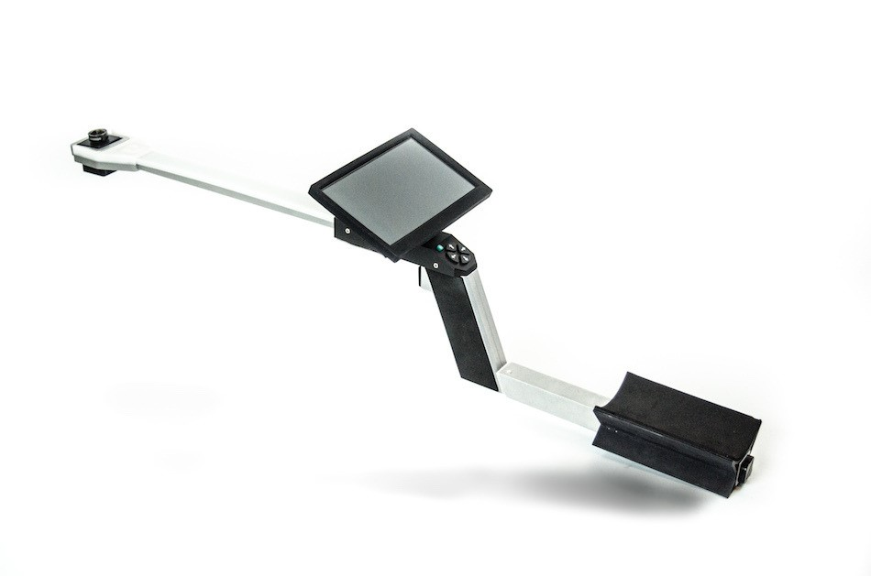
Operations Manual
PLANT CANOPY IMAGER
CI-110

DECLARATION OF CONFORMITY
Manufacturer:
CID Bio-Science, Inc.
1554 NE 3rd Ave
Camas, WA 98607
Declares that the CE-marked Product:

Product Model(s):
Model CI-110P

FCC Compliance Statement:
This device complies with part 15 of the FCC Rules. Operation is subject to the following two conditions: (1) This device may not cause harmful interference, and (2) this device must accept any interference received, including interference that may cause undesired operation.

Complies With:
89/336/EEC Electromagnetic Compatibility Directive
73/23/EEC Low Voltage Directive
Compliance Standards:
EN 55027 RF Emissions Information
Technology Equipment
EN 50082-1 EMC Immunity Standard
EN 60950 Safety of Information
Technology Equipment
Including Electrical
Business Equipment
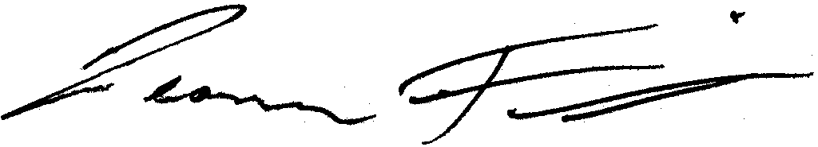

Leonard Felix
President
Contents
Introduction 1
Direct measurements 1
Calculations 1
Features and specifications 2
Getting Started 4
Starting and navigating the application 4
Recording a Measurement 5
Main Menu 6
Filename prefix 6
Data folder 6
Network 7
Export 7
Advanced 7
Camera filter 7
Camera alignment 7
PAR sensor calibration 8
Compass calibration 9
Software version 10
Shutdown 10
Measurement Settings Menu 11
Image 11
Brightness 11
Contrast 12
Red Filter 12
Blue Filter 13
Green Filter 13
GAP Fraction LAI 13
Threshold 14
Resolution 15
Zenith divisions 16
Azimuth divisions 17
PAR LAI 18
Leaf angle distribution 19
Light above canopy 19
Solar zenith 19
Sunflecks 20
Sampling period 20
Light threshold 20
Rename 21
Save 21
Save & Set Defaults 21
Delete 21
Image acquisition options 22
Trigger function 22
Exposure settings 22
Battery Replacement & Removal 23
Transferring Data via Removable Storage 23
Updating Device Software 23
Theory of Operation 25
Terminology 25
Hemispherical Photography 25
Gap Fraction 25
Extinction Coefficients 25
Leaf Angle Distribution 26
Leaf Area Index 26
Gap Fraction LAI 27
Image acquisition 27
Image classification 28
Calculations 28
PAR LAI 31
PAR LAI Terminology 31
Technical Support 35
Hardware Warranty 36
Literature 38

Introduction
The CI-110 Plant Canopy Analyzer is a unique tool that integrates two common methods of plant canopy analysis into one instrument. A self-leveling, wide-angled lens allows the user to capture hemispherical photographs for the analysis of leaf area index (LAI) and gap fraction analysis, while the photosynthetically active radiation (PAR) sensors in the arm of the instrument give the user alternative options for LAI calculation as well as additional information about radiation levels and sunflecks. This instrument is also seamlessly integrated with a corresponding software program, allowing for fast and simple analysis, leaving the user with immediate data on site. This user manual includes information for image acquisition and software use and can also be referred to for troubleshooting.

Direct measurements
The CI-110 directly measures:
- Gap fraction, or visible sky, through the image captured
- Photosynthetically active radiation through the 24-PAR sensors along the instrument’s arm
- Sunflecks through the PAR sensors
- Location and orientation by the installed GPS and compass

Calculations
The CI-110 calculates:
- Leaf area index (LAI)
- Leaf angle distribution
- Extinction coefficients
- PAR LAI

Features and specifications
The CI-110’s digital platform enables you to simultaneously capture wide-angle plant canopy images and estimate Leaf Area Index (LAI) and Photosynthetically Active Radiation (PAR) levels from a single canopy scan. LAI is used to characterize plant and forest canopies. This value ranges from 0-10, with 0 representing no canopy or bare ground and 10 representing a dense conifer forest canopy.
Specifications
Lens | Self-leveling hemispherical lens
Image Resolution | 8 megapixels
Interface | USB & Wi-Fi
Measuring Time | < 1 sec
Fish-Eye Lens Angle | 150°
Operating Temperature | 5 °C-50 °C
Weight | 1.5 kg
Total Length | 84 cm
PAR sensor bar & camera Length | 37 cm
Camera Sensor | 5 cm x 5 cm
USB Storage | 128 GB

There are 24 PAR sensors on the CI-110, located along the top of the arm spaced 10 mm apart. The PAR sensors are filtered GaAsP (gallium arsenide phosphide) photodiodes. The specifications are in the following table.
Par Sensor Specifications
Range | 0-2500 μmol/m² s
Accuracy | 5 μmol/m² s

Getting Started

Starting and navigating the application
Upon powering on the instrument, the software will automatically load on the display to the default starting screen. If measurements have been previously saved in the software, the starting display will show the existing images captured. If just beginning the application, the software will provide some instructions for getting started. See the Recording a Measurement section on page 5 for more details on capturing an image.
Navigation through the software can be performed in two ways. The touchscreen allows for easy navigation through touch. Alternatively, the four arrow keys can be used for software navigation.
- Use the up and down arrow keys for scroll options, whether that is through lists of numbers or letters
- Use the right and left arrow keys to select and enter and exit menu options
  - The right arrow key will enter the user into a menu system or select a current highlighted selection
  - The left arrow key will exit the user from a menu system or exit a user from the highlighted selection
The software has two menu systems, the Main Menu with options for data storage and network connections and the Measurement Settings menu for manipulation of the captured images and data analysis. The Main Menu is accessed on the left-hand side of the screen and can be reached by the left arrow key or through manual touch. The Measurement Settings menu system is located on the right-hand side of the screen and can be accessed by the right arrow key or through manual touch.

Recording a Measurement
- Power on the CI-110 Plant Canopy Imager by pressing the power button.
- Once the CI-110 has turned on, press and hold the measure trigger to start the live feed image.

Note: Releasing the trigger button will capture the image. Hold the trigger button depressed until ready to capture the image. Make sure to hold the trigger button for at least one second before releasing.

- Place the CI-110 under the canopy area for desired measurement.
- Orientate the image using the compass indicator until the top of the image is facing north.
- Use the up and down area keys on the keypad to adjust exposure settings to the desired level.
  - Alternatively, use the left arrow key to automatically set the exposure based upon current PAR levels.
- Release the measurement trigger to capture the image, the image is now available for further editing and analysis.
- Edit qualities of the image and analyze the data through the various options in the software (covered more in the following sections).
- Select “Save” to save your selected choices.

Main Menu
Upon opening the software or when viewing the list of current measurements saved on the instrument, press the left arrow key to enter the Main Menu. If at a different point in the software, the left arrow can be pressed multiple times until cycled to the Main Menu. Options in the Main Menu system include filename prefix settings, folder settings for saved measurements, available network connections, advanced settings for camera, PAR and compass details, and software shutdown.

Filename prefix
The filename prefix menu gives the user the ability to set a desired identifier for the file name. Upon saving a measurement, the file name will be the set prefix and the sequential number. For example, the prefix could be set to Lot1, and the tenth measurement would have the filename, “Lot1_10”. The filename prefix can be composed of letters and numbers.

Data folder
The data folder menu gives the end user a second level of organization for their saved measurements. Measurements will automatically be stored to the defaulted storage folder. To create a new folder for measurements, enter the data folder menu and select “Create New Folder.” Here the user can name the measurement folder. This can be a useful tool if capturing images in multiple areas that are part of the same project. For example, the measurement folder could be named the plot location, while the prefix could be labeled “block1” or other identifier for the given sampling area within the plot location.

Network
Network will show all the available networks for wireless connection as well as the strength of the connection. Selection of a network will prompt the user to enter credentials, as necessary.

Export
Press to save measurement data into a .csv (Comma-separated Value) type file on the instrument. Data can be accessed via the Wi-Fi or the USB drive in the hand hold of the instrument. This is required to access the numerical data on another device.

Advanced
The advanced menu options a submenu with options for camera, PAR sensor, and compass setting adjustment. See the details below for each sub menu option.

Camera filter
The CI-110 offers the ability to physically insert various filters behind the lens of the camera. Supplied with the purchase of the CI-110 are multiple neutral density filters that can be used to optimize the camera exposure under the many different light levels users encounter during image acquisition. If using one of the supplied neutral density filters, the optical density value of the filter should be entered under the camera filter setting.

Camera alignment
The camera is aligned at the factory so that the center of the image acquired is directly above the camera lens. Therefore, the images captured with the CI-110 will be aligned upon arrival. If the user desires an alternate alignment or the camera goes out of alignment, this menu setting can be used to adjust the center of the image.

X offset
Entering the X Offset submenu will show a list of alignment percentages. Scroll through the percentages to move the image along the x-axis. Selecting a more negative percentage will move the center of the image to the right while selecting a more positive percentage will move the center of the image to the left.

Y offset
Entering the Y Offset menu will show a list of alignment percentages. Scroll through the percentages to move the image along the y-axis. Cross hairs will appear on the image to represent the center of the image. Selecting a more negative percentage will move the center of the image down, while selecting a more positive percentage will move the center of the image up.

PAR sensor calibration
The PAR sensors along the arm of the CI-110 Plant Canopy Analyzer were calibrated at the factory. It would not typically be expected that an end user would need to recalibrate the PAR sensors. If, however, recalibration seems necessary, it can be done through this menu option. Entering the PAR sensor calibration menu with give users two options, to set the zero calibration and to set the span calibration.

Zero calibration
To set the zero for the PAR sensors, cover the sensors, or stand in a dark room. Enter the zero-calibration value in the software. To prevent against unintentional user manipulation of this value, the typical selection method (pressing the right arrow) is ineffective. After entering your zero-calibration interval, the user must hold down the trigger button while simultaneously pressing the right arrow to set the selection.

Span calibration
To set the span for the PAR sensors, one needs a known accurate, external PAR meter, such as a quantum sensor. Using the measurement from the alternative device, enter the span-calibration value in the software. To prevent against unintentional user manipulation of this value, the typical selection method (pressing the right arrow) is ineffective. After entering your span-calibration interval, the user must hold down the trigger button while simultaneously pressing the right arrow to set the selection.

Compass calibration
The compass was calibrated at the factory and should perform as expected upon instrument arrival. If the compass is not reporting accurately, recalibration may be necessary. Entering the Compass Calibration menu will walk the user through the proper steps for calibrating the compass. If the Compass Calibration menu was entered by mistake, simply press the left arrow to exit out of the calibration.
To begin, the device will prompt the user to:
- Press and hold the trigger button to confirm selection of calibration
- Release the trigger
- Slowly rotate the device along the Y axis or pitch
- Slowly rotate the device along the X axis or roll
- Slowly rotate the device along the Z axis or yaw
- Press and hold the trigger button
- Release the trigger button
At this point compass calibration is complete. Verify that the calibration was completed successfully with an external compass.

Software version
The current software version loaded onto the instrument will be visible under the Advanced submenu.

Shutdown
To shut down the instrument press the power button located above the arrow keys.

Measurement Settings Menu
The Measurement Settings Menu contains various options to both adjust the image captured by the CI-110 Plant Canopy Imager as well as to adjust the data reported by the instrument. To reach this menu use the up & down arrows till the image you are seeking is highlighted, press right once to reach the image data screen. Press right again to reach the Measurement Settings Menu.
Options for image adjustment include brightness, contrast, and color channel adjustment. Options for reported data adjustment can be separated into data adjustment for gap fraction LAI value versus adjustment for PAR LAI data and sun flecks. Other options under this menu system include options to save and delete captured images as well as to set default settings for image acquisition.

Image
The Image menu option includes tools available to adjust the captured hemispherical image. Specifically, adjustments to the image brightness, contrast, and color channels (Red Filter, Blue Filter, Green Filter) can be made here. The primary purpose of adjustment under this menu option is to optimize the acquired photograph for separation of foliage verses sky pixels. Users should only adjust the options here to optimize this separation.

Brightness
Adjusting the image brightness will either increase or decrease the luminance of the measurement image. Entering this menu option will present the user will the ability to adjust the brightness percentage of the image. Increase the percentage to increase the luminance and decrease the percentage to decrease the luminance.

Contrast
Adjusting the contrast of the measurement image will adjust he ratio between the brighter and darker pixels in the measurement image. Again, these are denoted in the software as percentages. If you increase the contrast percentage, this ratio between brighter and darker pixels will increase and the user will see clearer separation between the two.

Red Filter
Following available adjustments for brightness and contrast are options for color channel adjustments. The default settings for each of these colors filters is 0%. Entering the red filter option allows users to adjust the percentage of red color present in the image. An increase in percentage means a decrease in red in the captured image as it is filtering out the color.
If the hemispherical photograph was taken under very even sky conditions, increasing the red color channel can increase the contrast between foliage and sky elements. Under uneven sky conditions, it would not be recommended to increase the red color channel. Please note that increasing the red color channel would be achieved by increasing the filters for red and green in the software as this will decrease these colors and emphasize the red.

Blue Filter
Entering the blue filter option allows users to adjust the percentage of blue color in the image. Increasing the filter will decrease the blue color in the image.
Solely using the blue channel for one’s images is the most common approach to color channel adjustment for canopy analysis of hemispherical photography. Having only the blue channel in an image tends to darken foliage elements while making the sky appear more uniform in color. This can be useful under uneven sky conditions and when compensating for light scattering. Please note that in the software this would be accomplished by setting the green and red filter to 100% and leaving the blue filter at 0%.

Green Filter
Entering the green filter option allows user to adjust the percentage of green color in the image. An increase in percentage will decrease the amount of green color in the image.

GAP Fraction LAI
Canopy gap fraction is the probability of a ray of light passing through the canopy without encountering foliage or other plant elements. Gap Fraction LAI is the title given to the LAI index that is calculated based on the measured gap fraction of the image. For more details on the theory of gap fraction analysis, please see the Gap Fraction LAI section on page 27 in the Theory of Operation section of this manual.
The Gap Fraction LAI menu system includes adjustments for the reported gap fraction data. Here, users can change the threshold value used to separate pixels, the resolution of the image, and how the image is divided into corresponding zenith and azimuth divisions.

Threshold
Image thresholding is the segmentation of an image. In the case of the CI-110 Plant Canopy Analyzer, the greyscale image is thresholded to produce a binary image. The binary image is what determines the amount of foliage pixels (black) verses sky pixels (white) and resulting gap fraction values. For more details on this process please see the Image classification section on page 28 in the Theory of Operation section of this manual.
Choosing the threshold level is one of the most important determinants of the resulting measured leaf area index. Users want to choose the threshold level that most appropriately separates the foliage from the sky. The software gives three options for this process:
- Otsu method
- Entropy Crossover method
- Manually assigning a threshold percentage
The guiding determinant for which thresholding method should be chosen is which method gives the most accurate separation of your foliage elements from your sky elements. You can assess this by setting a threshold and evaluating the measured image (green and greyscale image) as compared to the captured image. Pixels that show up as green in the measured image correspond to foliage pixels, while pixels that show up as greyscale in the measured image are regarded as sky pixels.
The Otsu method is a commonly chosen method for mixed forest canopies. This thresholding approach is a clustering-based method which classifies the threshold of an image at which intra-class variance is minimized and interclass variance is maximized. If capturing images under a forest canopy during a set time where lighting will be consistently diffuse, such as at dawn or dusk, using the Otsu method can be a simple way to ensure consistency in the thresholding process across images.
The Entropy Crossover method uses a thresholding process that minimizes the differences between the input, or greyscale, image and the output, or binary, image.
The user can also manually adjust the threshold percentage as desired. If the pixel intensity within the image is greater or equal to the assigned percentage, it will fall into the sky category.

Resolution
The CI-110 gives the user ability to adjust the resolution of the acquired images. This setting will default to the highest resolution available. Typically, a higher resolution will allow for better separation of leaf from sky elements in the image. Lower resolutions may be chosen if file size is of concern.

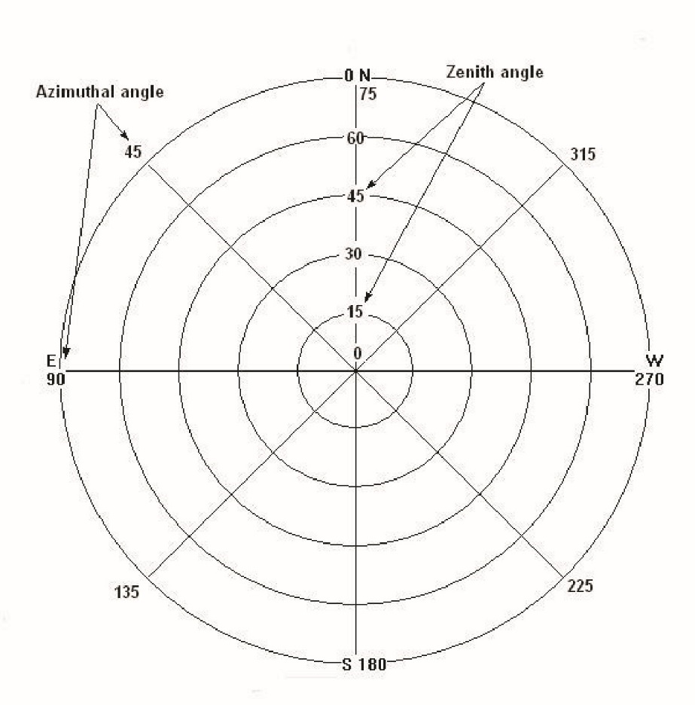
Zenith divisions
An acquired hemispherical image is divided for data analysis using the horizontal coordinate system. In this system, the observer’s local horizon is the primary plane. This horizontal coordinate system can be divided into zenith and azimuth divisions. The solar zenith angle is the angle between the zenith and the center of the sun and ranges from 0-90°. At sunrise and sunset, the solar zenith is approximately 90°. On the measured image, the zenith divisions are observed as rings.

Number of divisions
In the Number of Divisions submenu, one can designate the number of zenith divisions that the image is divided into. The number of divisions applicable by the end user range from 1 to 9. The software defaults to 18 zenith divisions as this is what is classically used in hemispherical photograph analysis. The user can see these divisions when viewing the measurement image.

Ending angle
The user of the CI-110 can not only dictate how many zenith divisions the hemispherical image is split into but also the ending angle for the analysis. This may be useful to exclude certain angles that a user does not want included in the data. The default ending angle for the zenith divisions is 75°. Often, it can be difficult to get the individual capturing the image out of the edge of the image. By setting the ending angle to 65° or lower, for example, the outer rim of the image will not be analyzed during the data collection.

Azimuth divisions
The other divisions used to classify hemispherical images acquired with the CI-110 are azimuth divisions. Images acquired with the CI-110 should be taken with the top of the image corresponding with north. This also corresponds to 0° for the azimuth angle. As the images are oriented in an upward facing direction, east will be located on the left-hand side of the image. Make sure to note that the azimuth angles then increase moving counterclockwise around the image, 0-360°. The divisions on the image can be viewed as pie slices.

Number of divisions
Under Number of Divisions, the user can choose how many azimuth divisions, or pie slices, to split the captured image into. The software will default to 8 divisions as this is what is classically used in hemispherical photograph analysis. The user can use up to 9 divisions.

Starting angle
Like the zenith divisions options, users can also dictate a starting angle for the azimuth divisions. The default setting for this is a 0° starting angle.

Ending angle
The user can also choose the ending angle for analysis. The default setting for this is 360° to include analysis for the entire circle.

PAR LAI
PAR LAI is the alternative way to calculate leaf area index with the CI-110 Plant Canopy Imager. Rather than using the gap fraction analysis from the captured hemispherical image, this calculation derives LAI by the amount of radiation above the canopy versus the amount of radiation below the canopy. This is measured through the twenty-four PAR sensors along the arm of the CI-110. The average PAR value across these sensors is reported on the main data screen upon capturing an image with the Canopy Analyzer. Individual PAR sensor response can be seen on the live updating graph in the upper right-hand corner of the main data screen.
For more details on the PAR LAI calculation please see the PAR LAI section on page 31 in the Theory of Operation section of this manual. Use of this feature requires some additional input by the user including leaf angle distribution (LAD), light above the canopy, and the solar zenith. Each of these is covered in more detail below.

Leaf angle distribution
The leaf angle distribution refers to the orientation of the leaves within the canopy. Please see the Leaf Angle Distribution and Extinction coefficient section on page 32 in the Theory of Operation section of this manual for more details. The CI-110 will default to a chi value of 1.0, which corresponds to a spherical distribution of the leaves within the canopy. If studying a crop with a known LAD, this can be manually inputted into the software here.

Light above canopy
Light above the canopy refers to the level of photosynthetically active radiation above the canopy being measured. The units for this are μmol/m²s and this metric is commonly referred to as the Photosynthetic Photon Flux Density (PPFD) or the number of photons in the 400-700 nm range received by a specified area over a given period.
This value can be directly measured using the PAR sensors in the arm of the CI-110 by going to an area without canopy obstruction and measuring the PPFD or a value can be directly entered into the software. This value will range from 1 to 2000 μmol/m²s.

Solar zenith
The solar zenith is the elevation of the sun along the zenith divisions of the hemisphere, with solar noon corresponding to 90° and sunrise and sunset corresponding to 0°. This index can be derived from the date and time of the image acquisition as well as the location of the image. In the software, the option to “Set using GPS Data” is available. This will automatically insert the solar zenith based on time and location. Alternatively, the end user may select their own solar zenith angle.

Sunflecks
Sunflecks are brief periods of direct solar radiation reaching below the canopy. The CI-110 measures sunflecks as the percentage of PAR sensors reading above a specified threshold. The sunfleck can also be visualized on the main data display while it is being measured on the PAR response graph, by a spike in the PAR sensor response, likely just across a few sensors. Details for setting up the CI-110 for sunfleck measurement can be found below.

Sampling period
Typically, sunflecks are distinguished from sun patches by the duration of the direct solar radiation below the canopy. Sunflecks are brief periods of direct solar radiation (a few seconds), while sun patches last much longer. The sampling period menu option allows the user to set the sampling time for sunfleck measurements.

Light threshold
The light threshold is the value at which any PAR sensors reading above that value will be included in the sunfleck reported percentage. For example, if the threshold is set to 300 μmol/m²s and 12 of the PAR sensors are reading above that value the sunflecks value will be reported as 50%.

Rename
This menu option allows a user to rename the viewed measurement. The name is originally generated in the filename prefix menu option in the main menu. If a user desires to change the prefix used on multiple measurements, they should make this adjustment in the Main Menu under Filename Prefix. The Rename menu option is appropriate to rename the selected measurement.

Save
Highlight Save and press the right arrow to save the changes made to the individual measurement file.

Save & Set Defaults
The Save & Set Defaults menu option allows the user to set the currently selected measurement settings as the default settings for further hemispherical photograph acquisition. This may be a good option for standardizing the acquisition of images at given location and time.

Delete
Highlight Delete and press the right arrow to delete the current measurement file.

Image acquisition options

Trigger function
Press and hold trigger to activate the camera and other sensors. Remove pressure to save current image and associated data. Make sure to hold the trigger for at least one second before releasing it. If the image appears blurry, the camera’s focus can be adjusted by rotating the lens.

Exposure settings
While holding the trigger button down, the screen will show both the real time image, light data from the sensors, and options for setting the exposure of the image.
The “up” arrow will increase the exposure, allowing more light into the aperture, and brightening the image. This will have corresponding effects on the initial computation of the leaf area to sunlight.
The “down” arrow will decrease the exposure, occluding the aperture and darkening the image. This will also have corresponding effects on the initial computation of the leaf area to sunlight.
The “Set Default” when pressed will cause subsequent image acquisitions to start at this level of exposure. You can change the exposure of the current image after pressing “Set Default,” release the trigger button to save the image. Taking a second image will start the exposure at the point when the “Set Default” was pressed.
The “Automatic Exposure” function sets the exposure level based upon information gained from the PAR sensors and the camera.

Battery Replacement & Removal
The CI-110 comes with two removal lithium-ion batteries contained in the device’s arm. To replace or remove these batteries, simply twist the battery cap found on the tip of the arm opposite of the camera counterclockwise. The cap may be attached by re-inserting the cap into its receptacle and twisting clockwise.
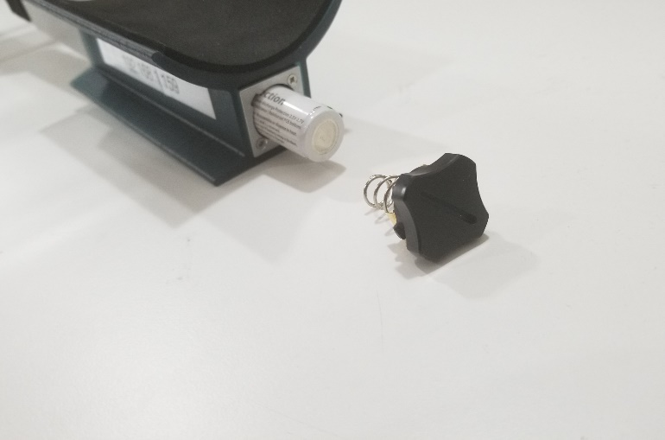

Transferring Data via Removable Storage
If a user wishes to transfer data collected with the CI-110 to another local machine, it is possible to disconnect the removable storage device attached to the USB port found on the underside of the CI-110. To begin, ensure the device is powered down. Once removed, the USB removable storage may be inserted into a PC for review.

Updating Device Software
To update the Plant Canopy Analysis software found on the CI-110, the device must first be connected to the same wireless network as the user’s desktop or laptop PC. Once connected, navigate to the main-menu of the CI-110 and note the devices IP address found under the “Network” heading. On the desktop or laptop PC, download the latest software release from the CI-110 software page and open it. Enter the IP address found on the CI-110 and input it into the software, pressing “Enter” when complete. The CI-110 will now begin updating, restarting on the latest software version once complete.

Theory of Operation

Terminology

Hemispherical Photography
The CI-110 Plant Canopy Analyzer contains the sensors and components necessary for many types of canopy analysis. One of the prime features of this instrument is its ability to capture hemispherical images of the plant canopy. The images captured by the CI-110 are considered hemispherical images because of their wide field of view of 150°. The image acquired can be imagined as a sort of dome overhead of the individual capturing the image, visualizing the plant canopy above them.
These kinds of images have classically been used for calculations of various plant canopy indices as well as to characterize and track solar radiation regimes. The main advantage of this approach is the permanent record that these images provide.

Gap Fraction
The gap fraction of an image is the proportion of visible sky. It can also be interchanged with a canopy openness percentage if multiplied by one hundred. The gap fraction is considered within each sector of the image. The sectors analyzed are determined by the set zenith and azimuth divisions by the user.

Extinction Coefficients
Described more below, the calculation for the reported gap fraction LAI reported in the CI-110 software is derived from an application of Beer’s Law. It is from this law that we use the term “extinction coefficients.” In relation to a forest canopy, the canopy light extinction coefficient $\left(K\right)$ is a parameter that describes the efficiency of light interception by the canopy. It is a key parameter for the calculation of leaf area index. A high $K$ value indicates high light interception by the canopy and thus, low levels of radiation penetration to the forest understory. Conversely, a low $K$ value indicates low light interception by the canopy and thus elevated levels of understory radiation.

Leaf Angle Distribution
The leaf angle distribution (LAD) of a plant canopy is the angular orientation of the leaves in the canopy. In LAI calculations, this is described mathematically as a statistical distribution of leaf angles on different planes. Plant canopies can range from having more erectophile leaf area distributions, such as onions which have very vertical orientation of their leaves, to more planophile, such as strawberries or oak trees that have more horizontal orientation of their leaves. It can be calculated from a hemispherical image if the gap fraction at many zenith angles is known. In the Calculations section on page 28, the LAD is denoted as $x$.

Leaf Area Index
Leaf area index (LAI) is the one-sided leaf area surface per unit ground surface area. It is a common index used to describe aspects of canopy structure as well as to describe and inform vegetative and atmosphere interactions. The CI-110 LAI index has been used to study photosynthetic response to plant density, nutrient uptake compared to plant biomass, and structural studies of deforestation and afforestation, among many others.
The CI-110 Plant Canopy Analyzer estimates an effective LAI through an iterative gap fraction inversion model. There are some assumptions in place for these algorithms to report accurately, such as the assumption of a randomly dispersed canopy.

Gap Fraction LAI
The main parameter of interest when using the CI-110 Plant Canopy Analyzer is the Leaf Area Index. The CI-110 can calculate this index in two different ways. The first is through gap fraction analysis of the hemispherical image. This analysis requires that the subsequent series of steps be followed.
- Image acquisition
- Image classification
- Calculations

Image acquisition
Image acquisition is the process of capturing the hemispherical image. The two primary considerations during image acquisition are proper orientation of the image and proper exposure for calculation of LAI. The CI-110 has automated methods that make these two requirements easy to meet.
During image capture, the user’s current orientation is indicated by the moving marker around the edge of the image. This marker will indicate when the image is orientated with north facing upward.
The various exposure options with the CI-110 were covered in the Exposure settings section on page 22.

Image classification
Image classification is the process of splitting the image into foliage verses sky elements. This is done through a process called thresholding. Thresholding is a method of image segmentation, classifying the image into two-pixel categories. The original captured image is transformed into a greyscale image first, and then the thresholding is done to produce a binary (black and white) image. The black pixels correspond to foliage elements while the white pixels correspond to sky elements.
These pixel categories are based on an analysis of the histogram of the different pixel intensities from the grey-scaled image. A threshold value is assigned at which the pixel intensities falling below the threshold are assigned to foliage, while pixels intensities at or above the threshold value are assigned to sky. This is one of the main reasons that typically users capture hemispherical images for gap fraction LAI analysis under diffuse lighting conditions. A varying sky, such as during mid-day, will have drastically different pixel intensities across the sky, making this thresholding process less accurate.

Calculations

Gap Fraction
Once the image has been properly classified, the gap fraction of the image can be analyzed. In each sector, a value between 0 and 1 is assigned; with 0 meaning no sky is visible below the canopy and 1 meaning that the entire area is sky, or no foliage canopy is present. From these measured transmittance values for leaf area index, mean leaf angle, and extinction coefficients can be calculated.

Leaf Area Index
The calculation of the LAI from the measured gap fraction of an image is an application of the Beer-Lambert law, modified in this case to describe characteristics of the canopy from the transmittance of light through it, or inversely, the extinction of light by the canopy elements.
To measure the LAI of the canopy, the gap fraction of the canopy must be measured, and the extinction coefficient of the canopy must also be derived. From there, an effective LAI can be estimated. The specific algorithms used by the CI-110 are from Norman and Campbell’s Gap-Fraction Inversion Procedure (Norman and Campbell, 1989) and Ellipsoidal Leaf Angle Distribution Parameter (ELADP) (Norman and Campbell, 1986). These algorithms are used to estimate effective LAI by solving simultaneous linear equations in which the gap fraction in each of several zenith angles is a function of effective LAI for a theoretical ellipsoidal canopy. The key calculations involved in this process can be seen below.
Leaf Area Index
- $τ_{φ_{i}}=e^{{-K}_{φ_{i}}L}$

Where:
$τ_{φ}=$ The transmission coefficient for the ray penetrations at each zenith angle
$K_{φ}=$ The extinction coefficient at each zenith angle
$i=$ The ith zenith angle division
$L=$ Leaf area index

Extinction coefficients
- $K_{φi}=\frac{\sqrt{x^{2}+\tan^{2}{φ_{i}}}}{A}$

Where:
$x=$ Leaf angle distribution (more explanation below)
$$A=x+1.774{\left(x+1.182\right)}^{-0.733}$$

Equation 1 is solved by finding values for $x$ and $L$ which minimize the function below using a least squares regression analysis.

- $F=\sum{{\left(\ln{τ_{i}+K\left(φ_{i},x\right)}\right)}^{2}}$

Subject to the constraint that $x˃0$. The minimum is found by solving $\frac{∂F}{∂L}=0$ and $\frac{∂F}{∂x}$ , simultaneously. The first equation results in

- $L={-\sum{\left[K\left(φ_{i},x\right)\ln{τ_{i}}\right]}}/{\sum{K{\left(φ_{i},x\right)}^{2}}}$

And the second,

- $L={-\sum{\left[{\ln{τ_{i}}∂K\left(φ_{i},x\right)}/{∂x}\right]}}/{\sum{\left[{K\left(φ_{i},x\right)∂K\left(φ_{i},x\right)}/{∂x}\right]}}$

To solve, $L$ can be eliminated between 4 and 5 and $x$ found by the bisection method. Once $x$ is known, $L$ can be solved from equation 1.

PAR LAI
The CI-110 Plant Canopy Analyzer can calculate leaf area index in a second manner, using the PAR sensors in the arm of the instrument. This calculation of LAI involves the same factors as the gap fraction LAI calculation with the exception that rather than use a gap fraction as determined from a hemispherical image, the PAR sensors are used to measure the transmittance of light through the canopy and from there derive the LAI. The PAR LAI calculation requires end users to input three values—the leaf angle distribution, light above the canopy and the solar zenith angle. From this information, the LAI can be calculated. More about options for inputting these values can be found in the PAR LAI menu section of this manual on page 18.

PAR LAI Terminology
This section addresses terminology specific to the PAR LAI calculation of the CI-110 Plant Canopy Imager.

PAR
Photosynthetically active radiation (PAR) is radiation within a certain wavelength, specifically, the wavelengths of light used for plant photosynthesis, 400 nm–700 nm. PAR values will vary throughout the day and be zero at night. As noted earlier in the manual, the units for the PAR values are μmol/m²s. The PAR detectors in the arm of the CI-110 are filtered gallium arsenide phosphide photodiodes.

Tau
Tau $\left(τ\right)$ is the ratio of below canopy PAR measurement to above canopy PAR measurement. This value is calculated by physically collecting these measurements with the instrument and entering the values for above canopy and below canopy PAR under the PAR LAI menu option. The CI-110 has no separate data logger for above canopy PAR measurements. Users can either collect this measurement under nearby open sky or can estimate this value based on location, date, and time.

Beam Fraction
The beam fraction $\left(f_{b}\right)$ is the ratio of direct beam radiation from the sun to radiation coming from all ambient sources. Incoming solar radiation can be reflected and scattered by both clouds as well as leaves in the canopy. Distinguishing the direct solar radiation from the reflected and scattered light is an important parameter of the LAI calculation. This value is derived mathematically and does not require end user input.

Leaf Angle Distribution and Extinction coefficient
The PAR LAI calculation requires that the user input the leaf angle distribution. This parameter does not have a large error influence on the leaf area index calculation. If unsure of the proper value, a default value of 1 can be used. This assumes a spherical distribution of leaves. See the discussion on Leaf Angle Distribution in the Gap Fraction LAI section on page 27 in the Theory of Operation section for a better idea of what a canopy could be classified as.
For horizontal leaves $x→∞$, and
$$K_{φ_{i}}=1$$
For vertical leaves $x→0$, and
$$K_{φ_{i}}=\frac{2tanφ_{i}}{π}$$
For spherical leaves $x→1$, and
$$K_{φ_{i}}=\frac{1}{2cosφ_{i}}$$
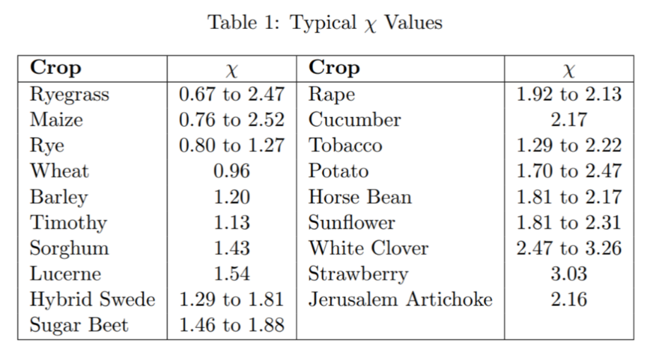
You can set the value specific to the crop or species you are predominately focused on. The following table gives typical Chi values for some crops:
Table 1

PAR LAI
The CI-110 uses the model from John Norman for predicting scattered and transmitted PAR and inverts it to find PAR based LAI.
$$L= \frac{\left[\left(1-\frac{1}{2K}\right)f_{b}-1\right]\ln{τ}}{A\left(1-0.47f_{b}\right)}$$
Where:
$L=$ leaf area index
$$A=0.283+0.785a-0.159a^{2}$$
$a=$ leaf absorptivity in PAR wavelengths of light; this value can range from around 0.5–0.9, the CI-110 uses 0.9.
$f_{b}=$ beam fraction
$τ=$ ratio of below canopy PAR to above canopy PAR

Technical Support
If you have a question about the CI-110, first look in the CI-110 Instruction Manual. There is also online support available for the CI-110 at www.cid-inc.com/support/CI-110/. If you cannot find the answer, you can contact a Technical Support Representative located in your country. CID Bio-Science is committed to provide customers with high quality, timely technical support. Technical support representatives are to answer your technical questions by phone or by e-mail at support@cid-inc.com.
CID Bio-Science, Inc’s contact information:
CID Bio-Science
1554 NE 3rd Ave
Camas, WA 98607 USA

Phone: 800-767-0119 (U.S. and Canada)
360-833-8835
Fax: 360-833-1914

Website: http://www.cid-inc.com
E-mail: support@cid-inc.com

Customers sometimes find that they need CID Bio-Science to upgrade, recalibrate or repair their system. In order for CID Bio-Science to offer these services, the customer must first contact us and obtain a Return Merchandise Authorization (RMA) number. Please contact a customer service representative for specific instructions when returning a product. You can e-mail support at support@cid-inc.com.

Hardware Warranty
Seller’s Warranty and Liability:
CID Bio-Science warrants new equipment of its own manufacturing against defective workmanship and materials for a period of one year from date of sale. The results of ordinary wear and tear, neglect, misuse, accident, and excessive deterioration due to corrosion from any cause is not to be considered a defect.
CID Bio-Science, Inc.’s liability for repairing or replacing defective parts during the warranty period is contingent on examination by a CID Bio-Science authorized representative. CID Bio-Science, Inc.’s liability will not extend beyond repairing or replacing parts from the factory where they were originally manufactured. Repair or alteration by an unauthorized technician voids warranty.
Material and equipment which is not manufactured by CID Bio-Science, Inc. is to be covered only by the warranty of its manufacturer. CID Bio-Science will not be liable to the Buyer for loss, damage, or injury to persons or to property by the use of equipment manufactured by other companies.
Buyer accepts the terms of warranty through use of this instrument and any accessory equipment. There are no understandings, representations, or warranties of any kind, express, implied, statutory, or otherwise (including, but without limitation, the implied warranties of merchantability and fitness for a particular purpose), not expressly set forth herein.
All instrument repairs or replacement covered under warranty require a Returned Material Authorization (RMA) number. Please contact CID Bio-Science technical support department at support@cid-inc.com to obtain an RMA number before shipping instrument to CID Bio-Science, Inc.
Buyer is responsible for shipping charges to CID Bio-Science, Inc. headquarters:
1554 NE 3rd Ave.
Camas, WA 98607
USA

CID Bio-Science, Inc. is responsible for return shipping charges on repairs and/or replacement covered by warranty.

Literature
Campbell, G. S. 1986. Extinction coefficients for radiation in plant canopies calculated using an ellipsoidal inclination angle distribution. Agric. For. Meteorol., 36: 317-321.
Campbell, G.S. and J. M. Norman. 1977. An Introduction to Environmental Physics. Springer-Verlang New York Inc. New York, pp. 247-277.
Campbell, G.S. and J. M. Norman. 1988. The description and measurement of plant canopy structure. In Plant Canopies: Their Growth, Form and Function (ed. G. Russell), Society for Experimental Biology, Seminar Series 29, Cambridge University Press, New York.
Chen, J.M. et al. 1991. Evaluation of hemispherical photography for determining plant area index and geometry of a forest stand. Agricultural and Forest Meteorology, 56: 129-143.
Norman, J.M. and G.S. Campbell. 1989. Canopy structure. Plant physiological ecology: Field methods and instrumentation. Eds. R.E. Pearcy, J.R. Ehleringer, H.A. Mooney and P.W. Rundel. London, Chapman and Hall. pp. 301-325.
Norman, J.M. and P.G. Jarvis. 1974. Photosynthesis in Sitka Spruce (Picea sitchensis (Bong.) Carr.) III. Measurements of canopy structure and interception of radiation. J. Appl. Ecol. 12:839-878.
Table 1: Decagon AccuPAR LP-80 Retrieved 24 April 2018 from http://manuals.decagon.com/Manuals/10242_Accupar%20LP80_Web.pdf

